UV Curing

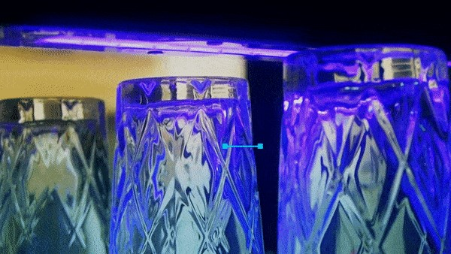

UV Curing
UV Curing，also known as “ ultraviolet light curing”is an application example of using “ ultraviolet(UV)”to cure and accelerate solidification of resin. This technology has the advantages of resources、space、less waste and high productivity such characteristics have attracted attention in recent years under the esteem of “ environmental protection chemistry”.

The rise of environmental protection chemistry
In the last 2 centuries, since the industrial revolution changed the structure of human society, it also greatly changed the structure of the earth`s nature. Scientists around the the world called for the future of the earth`s future if effective governance is no longer implemented afraid that pollution will not allow people to survive, so the rise environmental protection chemistry is to focus on the design of substances or reaction as little as possible , not to produce harmful compounds ,and to make chemical synthesis reactions that do not damage the environment during the manufacture of chemical products. Compared with the past, countries around the world are now more aware of the key to solving environmental problems, that is “ no generation of non-polluting substances”campaign. This is the rise of environmental protection chemistry .

UV Curing- 2 type of UV Curing
According to different curing principles, ultraviolet-curing resin and other light curing materials can be divided into two categories : free radical compound type and cationic compound type. In the past, the mainstream of the market was mostly free-radical compound type, but this type will have problems such as oxygen hindering surface curing. Therefore,
the development of cationic type without this problem has developed rapidly in recent years.
Compatibility, or various characteristics such as film curing (no oxygen barrier), which can make up for the shortcomings of the free radical type , is expected to become a new material to expand the market of lightcurable materials.

RUCO 920UV Series - Wear corrosion-resistant and accelerated drying
The German RUCO 920UV series, which is the sole agent of the Finecause company, use a unique new formula. It uses different wavelengths and energies to allow the monomers in the ink connection to be polymerized into a polymer, which indirectly make the ink into film. Very good adhesion. At the same time it has the characteristics of wear resistance, corrosion resistance and accelerated.
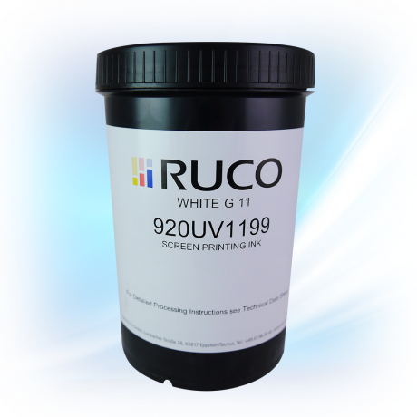
https://www.finecause.com.tw/

